# CS 255 System Design Document Template

## UML Diagrams

### UML Use Case Diagram

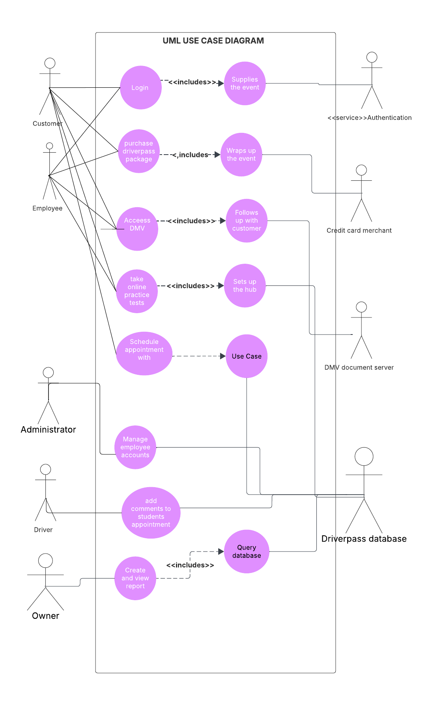

### UML Activity Diagrams

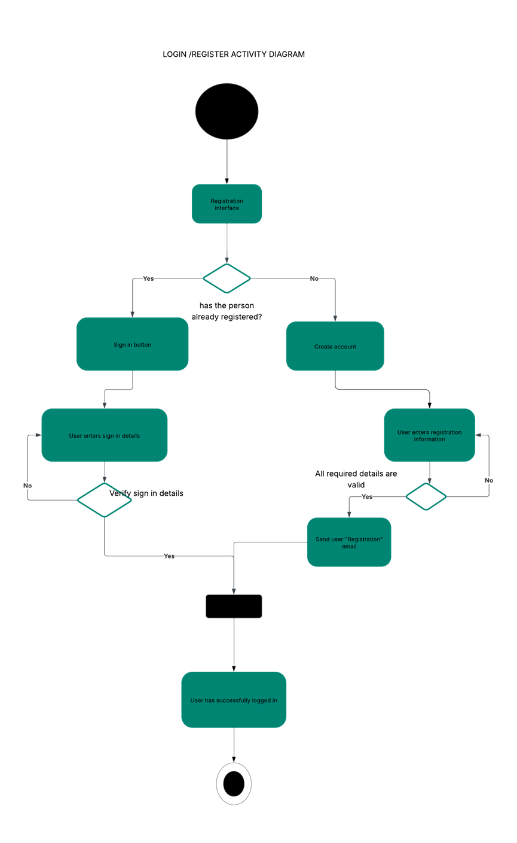

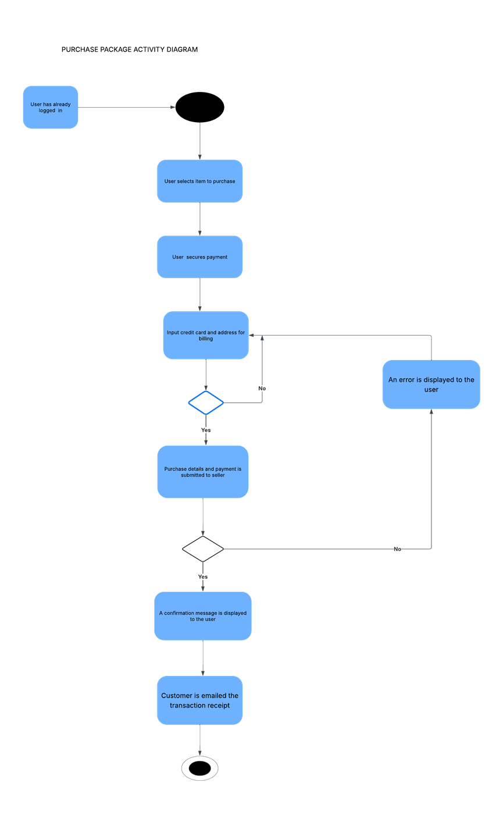

### UML Sequence Diagram

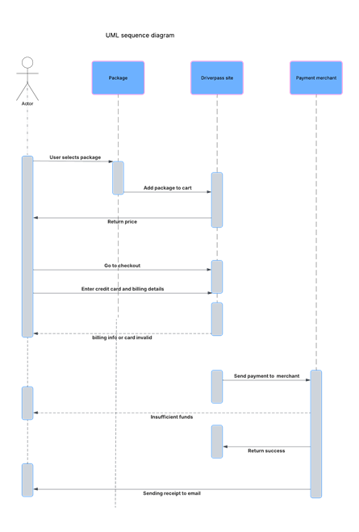

### UML Class Diagram

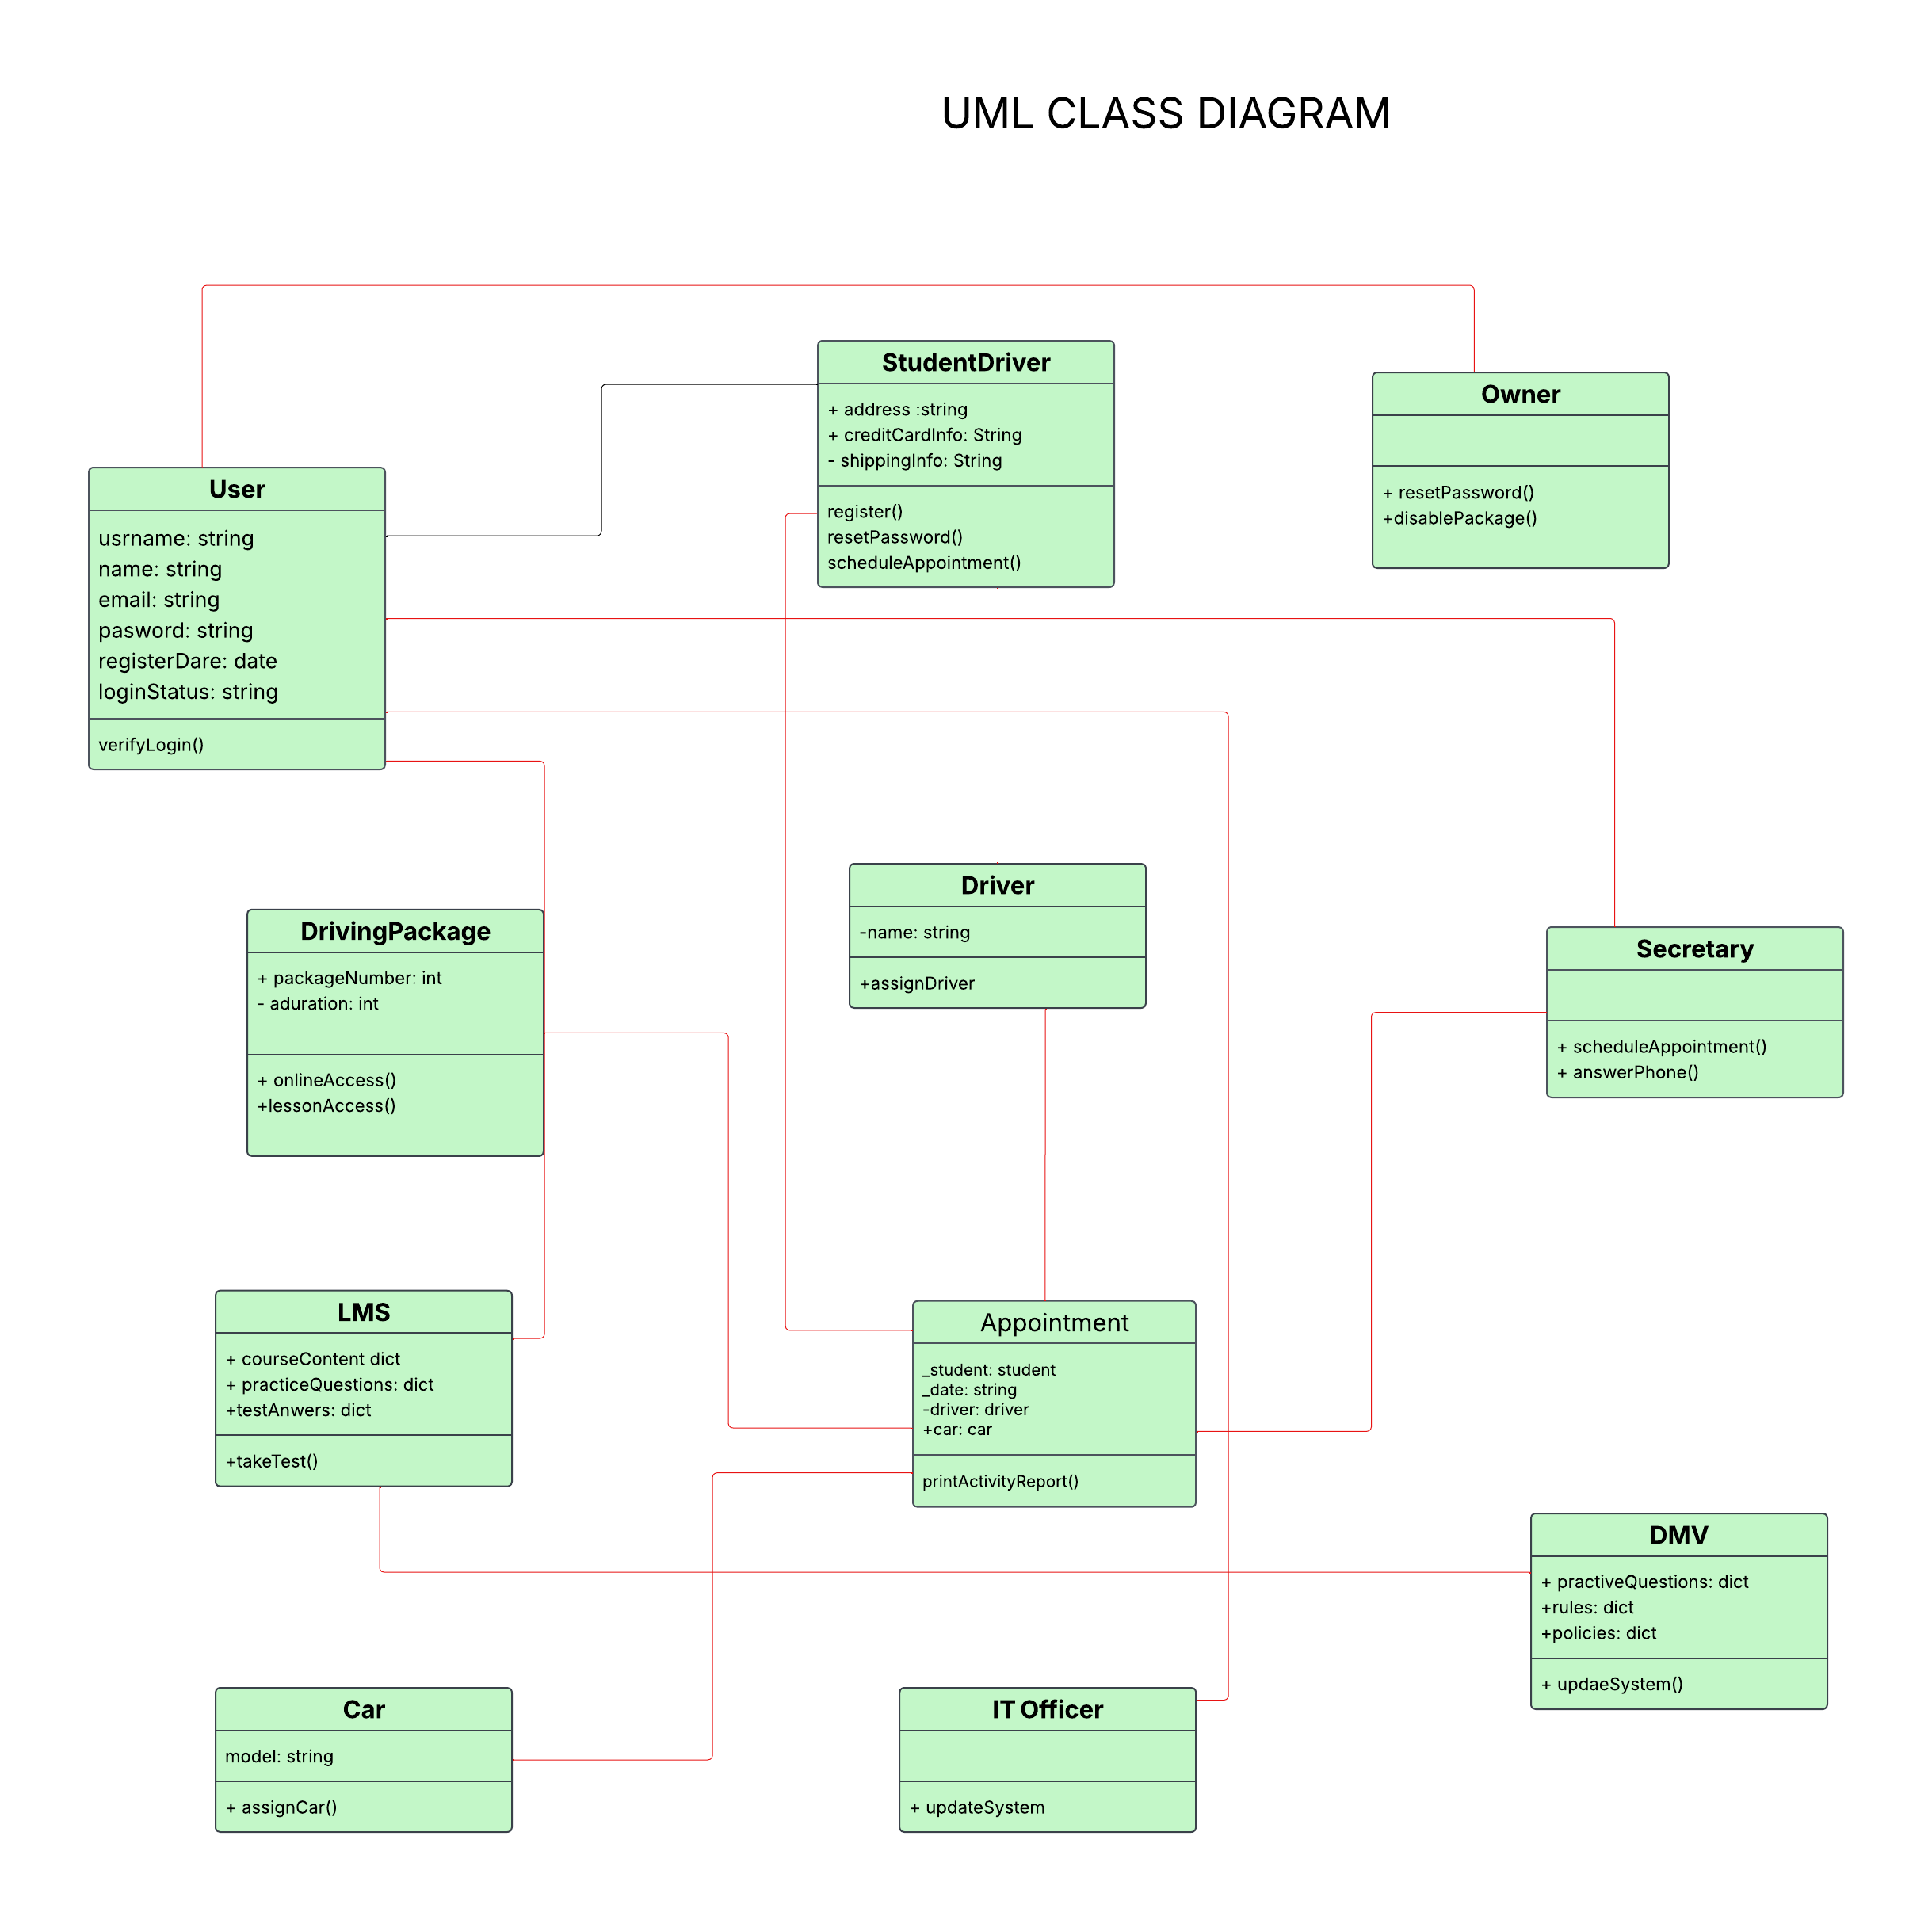

## Technical Requirements

To use the system efficiently, users will need a computer or smartphone that has internet capabilities. The system will be run on a server or cloud provider who owns all the data and runs the backend. The backend will be coded in a language like Node.js or PHP, whereas the frontend will be coded in HTML, CSS, and JavaScript so that users can have an easy interface with the system through a web browser like Chrome or Firefox. The system will keep its major information in a database like MySQL. The code will be written by developers in a code editor like Visual Studio Code and controlled in GitHub. There are tools like draw.io to help develop system diagrams and Postman can be employed for checking if all things work right. To have security, the system needs to employ HTTPS along with a login mechanism so that only certain authorized individuals are allowed to utilize a feature.